# Comparison from Stata mimix output with R output for selected individuals

## Estimates for J2R – jump to reference

Using Stata command

mimix fev treat, id(id) time(time) method(j2r) refgroup(2) covariates(base) clear m(10000) seed(301)

The Following shows Stata output followed by R output, both J2R using seed 301 for given individuals

Figure Figure 16 mimix fev treat, id(id) time(time) method(j2r) refgroup(2) covariates(base) clear m(10000) seed(301) 5456

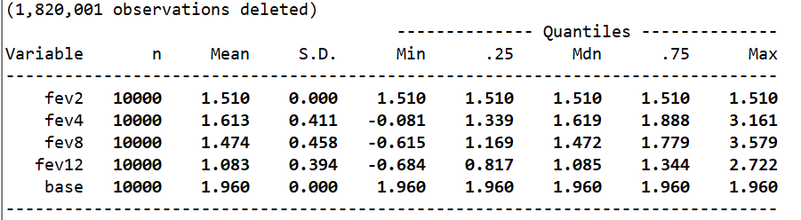

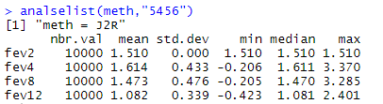

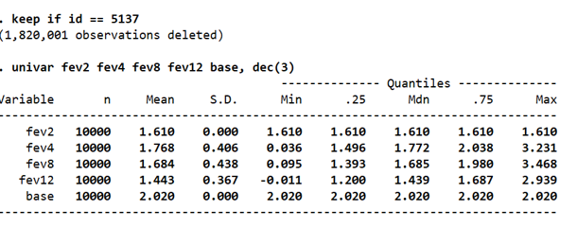

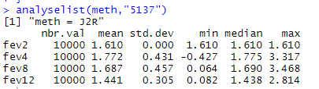

pttestf(10000,10000,1.768,0.406,1.772,0.431)

[1] 0.2496679

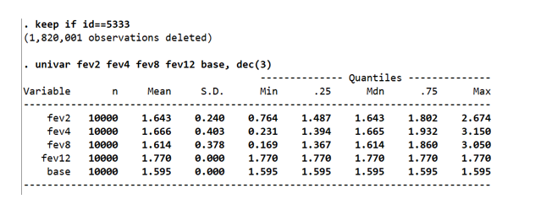

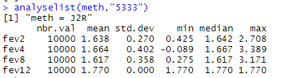

pttestf(10000,10000,1.638,0.27,1.643,0.240)

[1] 0.08317297

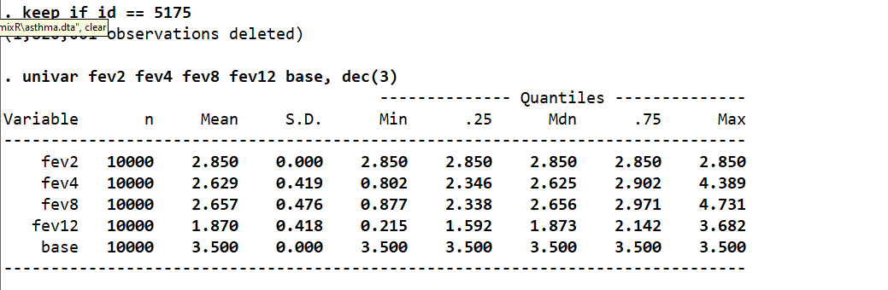

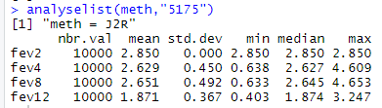

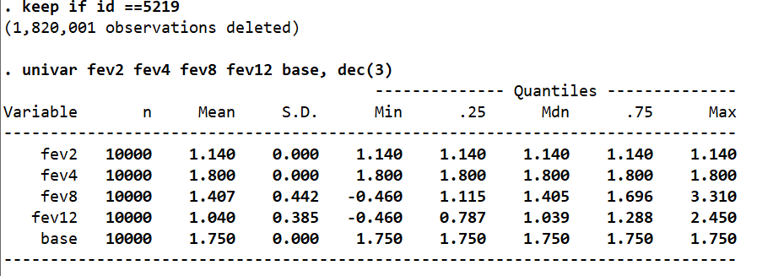

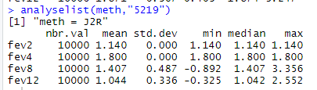

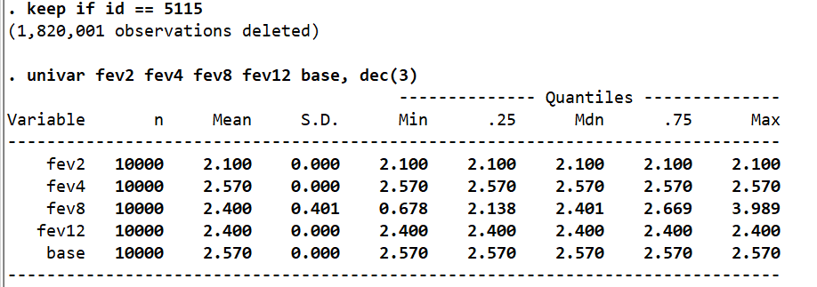

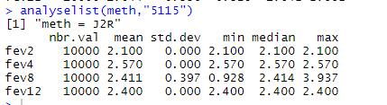

**CIR Copy increments in reference**

Figure mimix fev treat, id(id) time(time) method(cir) refgroup(2) covariates(base) clear m(10000)

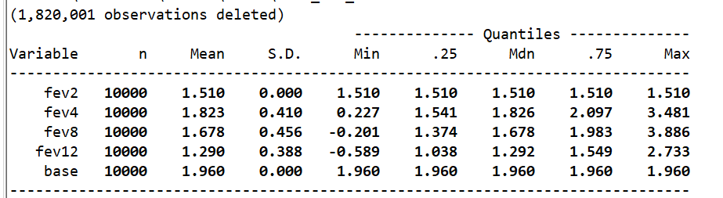

Figure seed =201

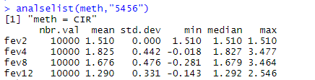

Figure seed = 301

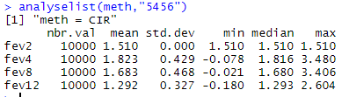

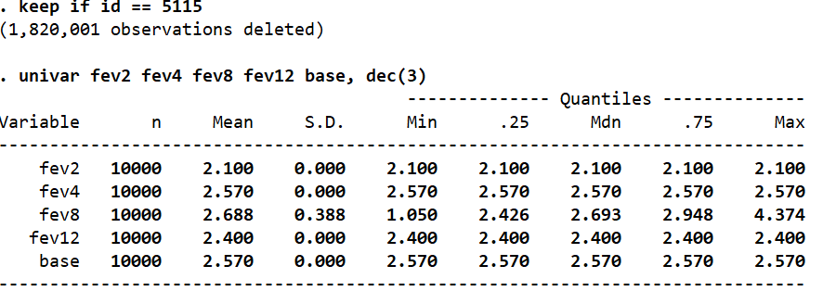

Figure seed 101

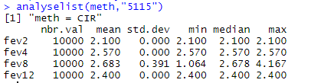

Figure seed =201

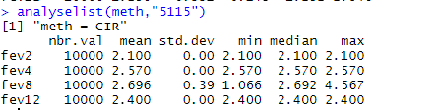

**CR Copy Reference**

Figure . mimix fev treat, id(id) time(time) method(cr) refgroup(2) covariates(base) clear m(1000) seed(101)

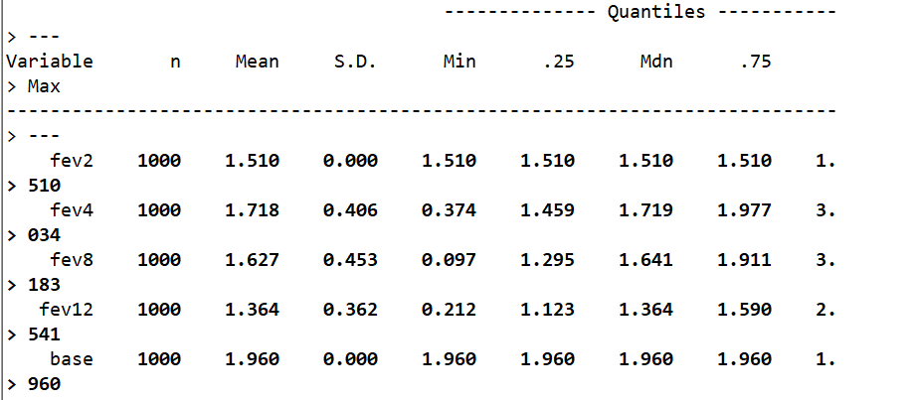

Figure seed 101

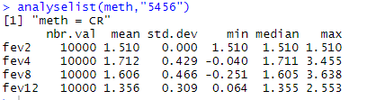

## LMCF Last mean carried forward

Figure . mimix fev treat, id(id) time(time) method(lmcf) refgroup(2) covariates(base) clear m(1000) seed(101)

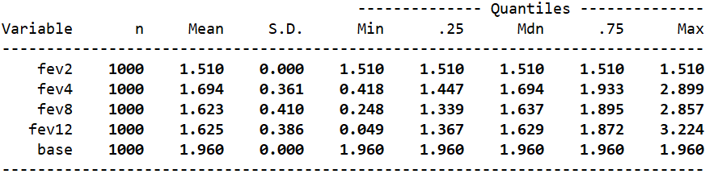

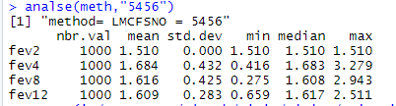

## MAR Missing at random

Figure Figure 11 . mimix fev treat, id(id) time(time) method(mar) refgroup(2) covariates(base) clear m(1000) seed(101)

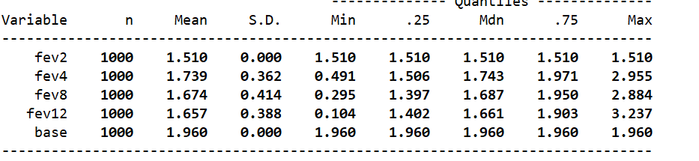

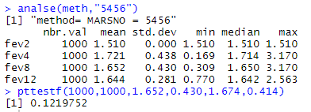

## Running regressions on imputed data sets

lm(fev12~as.factor(treat)+ base)

# Assign list of input parameters

kmargs <- list("fev","treat","id","time","base",1000,2,"J2R",101)

Figure R output

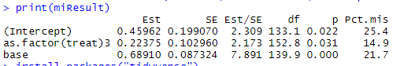

Figure mimix fev treat, id(id) time(time) method(j2r) refgroup(2) covariates(base) clear m(1000) regress seed(101)

